

# Perth Modern School

### Semester Two Examination, 2016

### Question/Answer Booklet

# MATHEMATICS

Student Name: _______________________

Teachers Name: ____________________

**SPECIALIST**

**UNITS 3 AND 4**

## Section Two:

## Calculator-assumed

|  |  |  |  |  |  |  |  |  |
| --- | --- | --- | --- | --- | --- | --- | --- | --- |
| Student Number: In figures |  |  |  |  |  |  |  |  |

In words

## Time allowed for this section

Reading time before commencing work: ten minutes

Working time for section: one hundred minutes

## Materials required/recommended for this section

***To be provided by the supervisor***

This Question/Answer Booklet

Formula Sheet (retained from Section One)

***To be provided by the candidate***

Standard items: pens (blue/black preferred), pencils (including coloured), sharpener, correction fluid/tape, eraser, ruler, highlighters

Special items: drawing instruments, templates, notes on two unfolded sheets of A4 paper, and up to three calculators approved for use in the WACE examinations

## Important note to candidates

No other items may be taken into the examination room. It is **your** responsibility to ensure that you do not have any unauthorised notes or other items of a non-personal nature in the examination room. If you have any unauthorised material with you, hand it to the supervisor **before** reading any further.

## Structure of this paper

|  |  |  |  |  |  |
| --- | --- | --- | --- | --- | --- |
| Section | Number of questions available | Number of questions to be answered | Working  time (minutes) | Marks available | Percentage of exam |
| Section One:  Calculator-free | 8 | 8 | 50 | 52 | 35 |
| Section Two:  Calculator-assumed | 12 | 12 | 100 | 97 | 65 |
|  | | | **Total** | 149 | 100 |

## Instructions to candidates

1. The rules for the conduct of examinations are detailed in the school handbook. Sitting this examination implies that you agree to abide by these rules.

2. Write your answers in this Question/Answer Booklet.

3. You must be careful to confine your response to the specific question asked and to follow any instructions that are specified to a particular question.

4. Spare pages are included at the end of this booklet. They can be used for planning your responses and/or as additional space if required to continue an answer.

* Planning: If you use the spare pages for planning, indicate this clearly at the top of the page.
* Continuing an answer: If you need to use the space to continue an answer, indicate in the original answer space where the answer is continued, i.e. give the page number. Fill in the number of the question that you are continuing to answer at the top of the page.

5. **Show** **all your working clearly**. Your working should be in sufficient detail to allow your answers to be checked readily and for marks to be awarded for reasoning. Incorrect answers given without supporting reasoning cannot be allocated any marks. For any question or part question worth more than two marks, valid working or justification is required to receive full marks. If you repeat any question, ensure that you cancel the answer you do not wish to have marked.

6. It is recommended that you **do not use pencil**, except in diagrams.

7. The Formula Sheet is **not** to be handed in with your Question/Booklet.

Section Two: Calculator-assumed 65% (97 Marks)

This section has**twelve (****12)** questions. Answer **all** questions. Write your answers in the spaces provided.

Working time for this section is 100 minutes.

Question 9 (17 marks)

Consider the functions .

(a) (i) Determine the expression for and explain why the function is defined. (2)

(ii) Explain why the function  has an inverse. (1)

(iii) Find the equation of the inverse of the function . (3)

(b) (i) Find the domain such that the function  exists. (3)

(ii) Determine whether the function  is a one to one function given

. (3)

(c) (i) Given  sketch  on the set of axes below. (3)

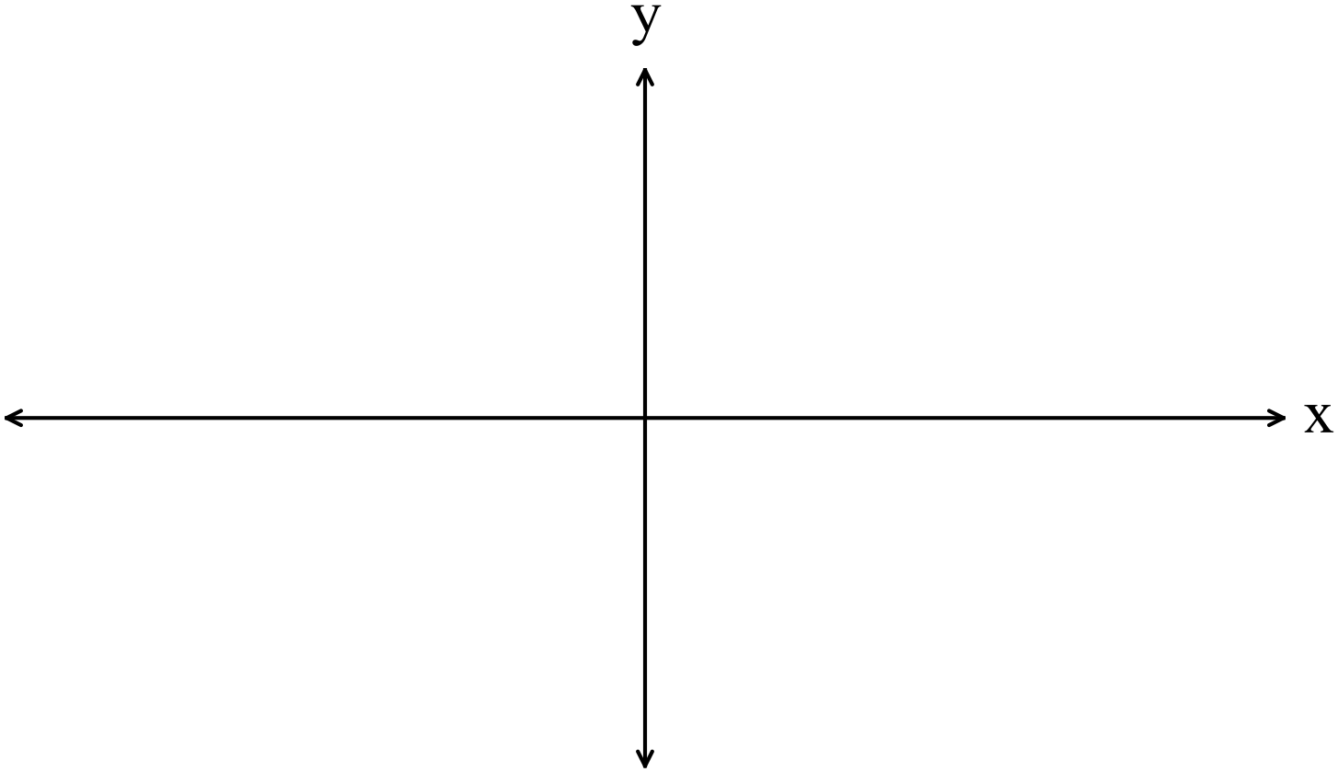

(ii) Find  (2)

Question 10 (5 marks)

Use the expansion of  to show that 

Question 11 (10 marks)

(a) Define the shaded region graphed on the set of axes below. (3)

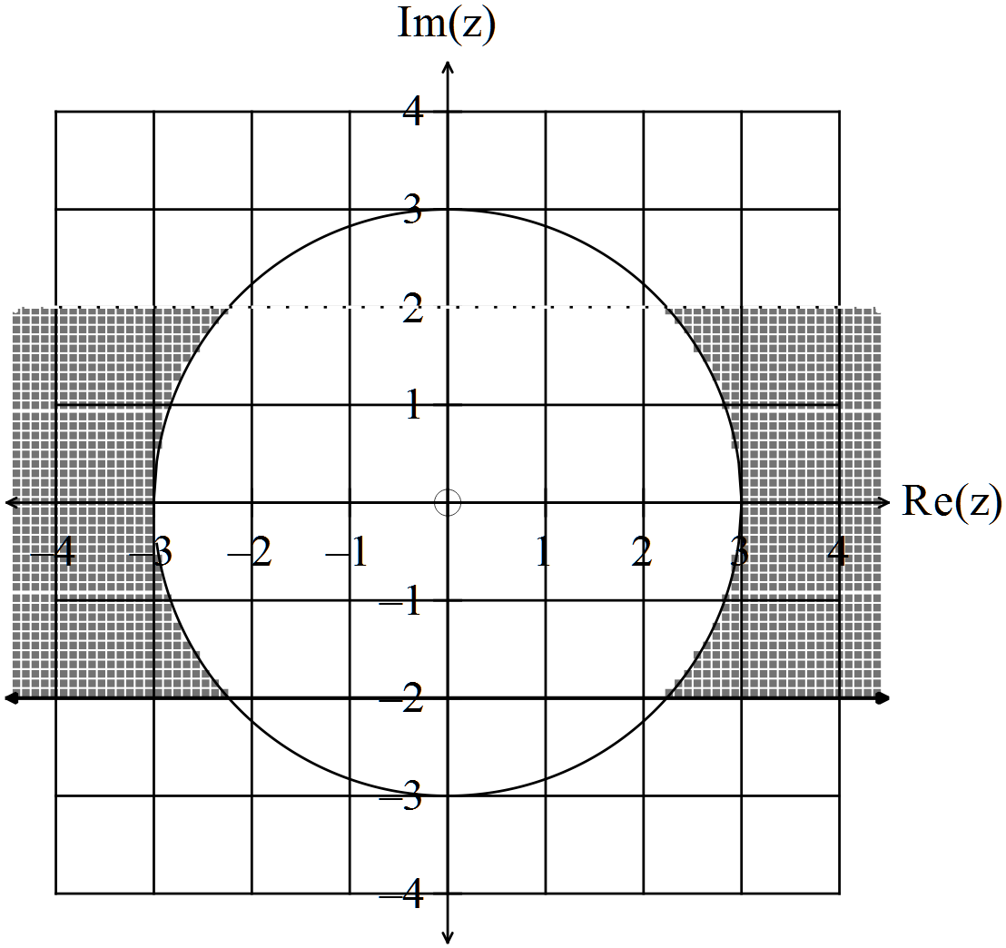

(b) Given  prove that . (3)

(c) Sketch  on the set of axes below.

Hint: Put  (4)

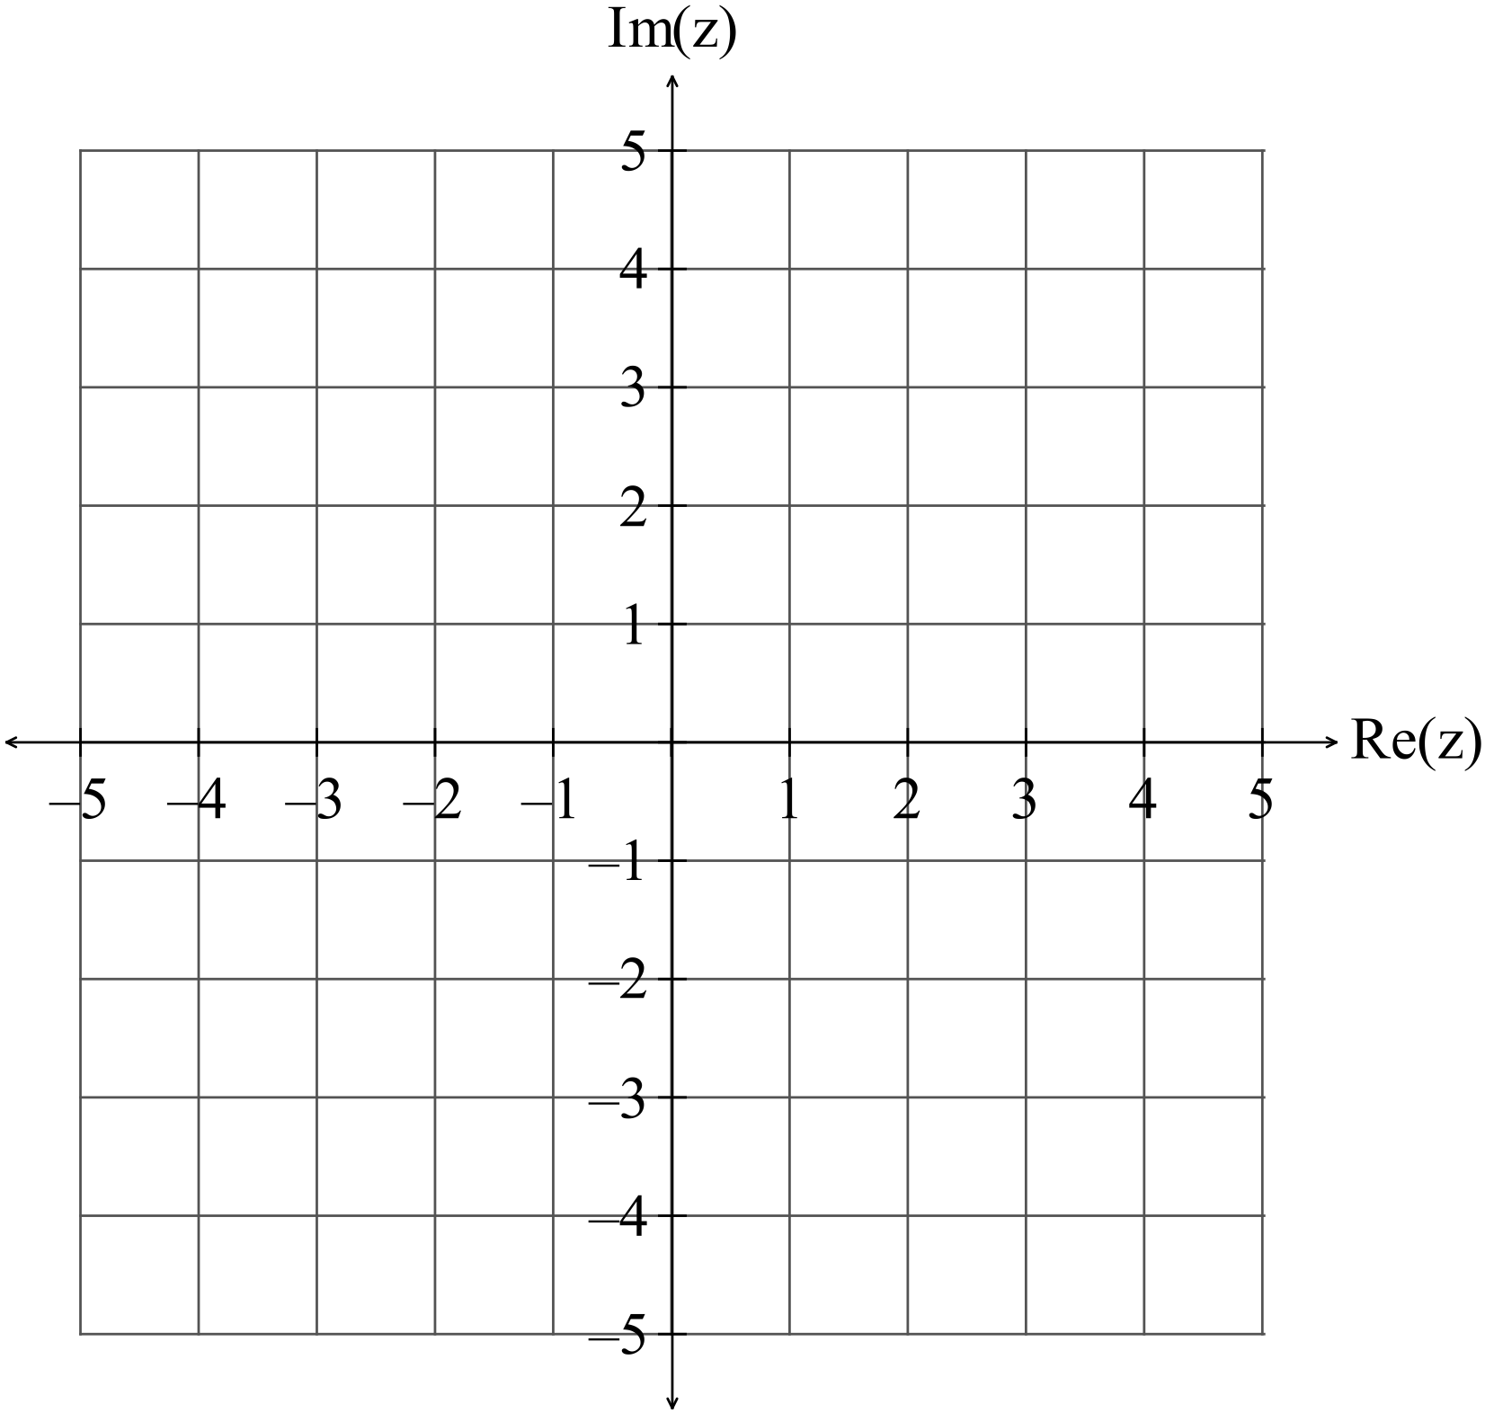

**Question 12 (6 marks)**

The line 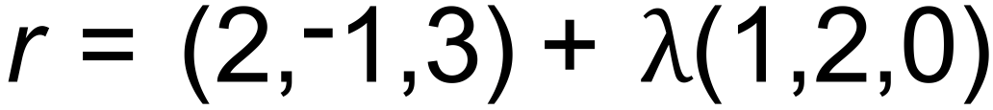 and the plane ***r.***<***i*** – ***j*** + 2***k***> = 2 intersect at point *P*.

(a) Determine the coordinates of *P*. (3)

(b) Determine the size of the angle between the line and the plane. (3)

**Question 13 (4 marks)**

Given the vector equation of a plane is

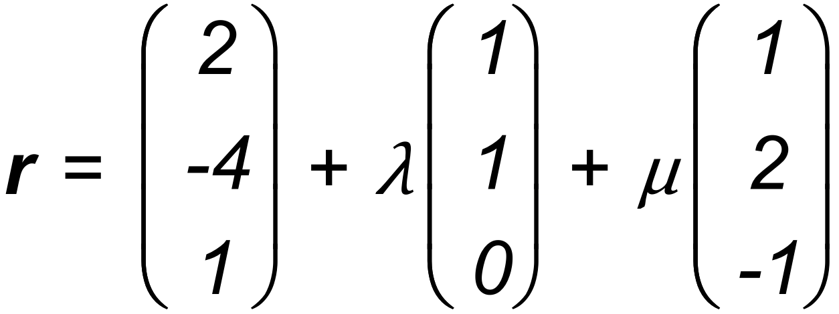

(a) Show that the point (2, 2, -1) belongs to the plane. (2)

The Cartesian equation of the plane is *x* – *y* – *z* = 5

(b) Find the equation of a line that is perpendicular to the plane and contains

the point (2, 2, -1) (2)

Question 14 (9 marks)

|  |
| --- |
| The position of a small body relative to the origin at any time *t* seconds is given by  the vector function , . |
| (a) Determine an expression for , the velocity of the body, and prove that the velocity of the small body is always perpendicular to its position vector for all *t*. (4) |
| (b) Show that the body is travelling with constant speed and describe the motion of the body. (3) | |
| (c) Explain why  for any  (2) |

**Question 15 (8 marks)**

The standard deviation of the lifetimes of Bright light bulbs is 770 hours.

Quality control experts plan to estimate μ, the mean lifetime of Bright bulbs, using the mean lifetime of a random sample of Bright bulbs.

(a) The experts would like to be 95% confident that the mean lifetime of bulbs in the sample is within 15 hours of μ. How large a sample should they take? (3)

(b) Suppose that a random sample of 100 Bright light bulbs is taken, and the mean lifetime of these bulbs is 10540 hours.

Based on this sample, determine a 90% confidence interval for μ. (3)

(c) The manufacturer claims that the mean lifetime of Bright Bulbs is at least 10 000 hours.

Does the sample in Part (b) provide a strong reason to doubt this claim? Justify your answer. (2)

**Question 16**

**(3 marks)**

A coffee machine is intended to produce cups of coffee with a mean temperature

between 74 °C and 78 °C. However, the temperature of coffee produced is in fact uniformly distributed between 70 °C and 80 °C, with a mean of 75 °C and a standard deviation of 2.89 °C.

Use the Central Limit Theorem to estimate the probability that the mean temperature of the next 50 cups of coffee produced by the machine will lie between 74 °C and 78 °C.

Give the answer correct to **two (2)** decimal places.

Question 17 (8 marks)

(a) Given  find an expression for  in terms of  given that (1,1)

belongs to the curve. (4)

(b) If  then find the velocity when  (4)

HINT: 

**Question 18 (6 marks)**

Given the functions  and  defined on the interval .

(a) find the exact values where . (3)

(b) hence determine the area enclosed between the two curves correct to three decimal places. (3)

Question 19 (12 marks)

(a) The logistic differential equation is  where  represents

population,  the carrying capacity and  is a positive constant.

(i) Explain what happens to the term  as and how the change affects the growth curve. (2)

(ii) Show that  where  (5)

**HINT: Use partial fractions.**

(b) The total number of ebola cases () in Sierra Leone can be represented by the

function  where  represents the number of months since February 2014.

(i) Determine the number of cases in February 2015 and in August 2015. (2)

(ii) Explain how to determine when the rate of the number of ebola cases stops increasing (but is still positive).

Refer to the graph below to indicate the point where this occurs. (2)

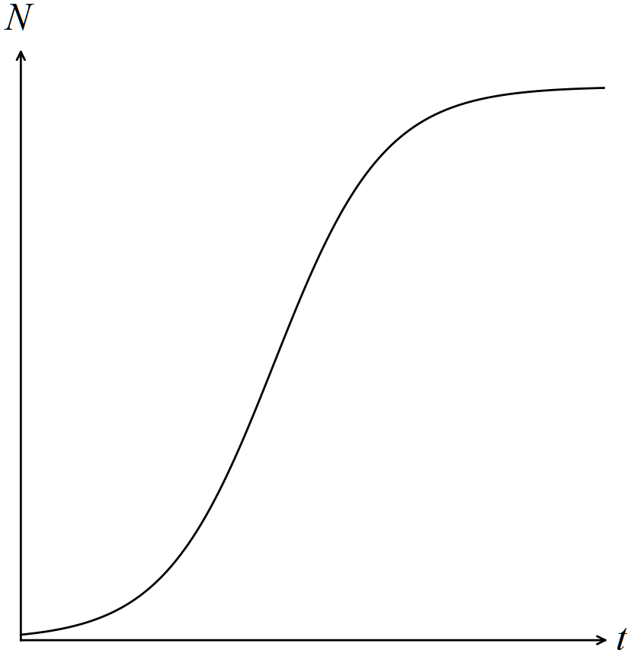

(iii) What is the expected number of total cases? (1)

Question 20 (5 marks)

(a) Sketch the function that goes through the points

(i) (1, 0) (2)

(ii) (2, 2) (1)

on the direction field below.

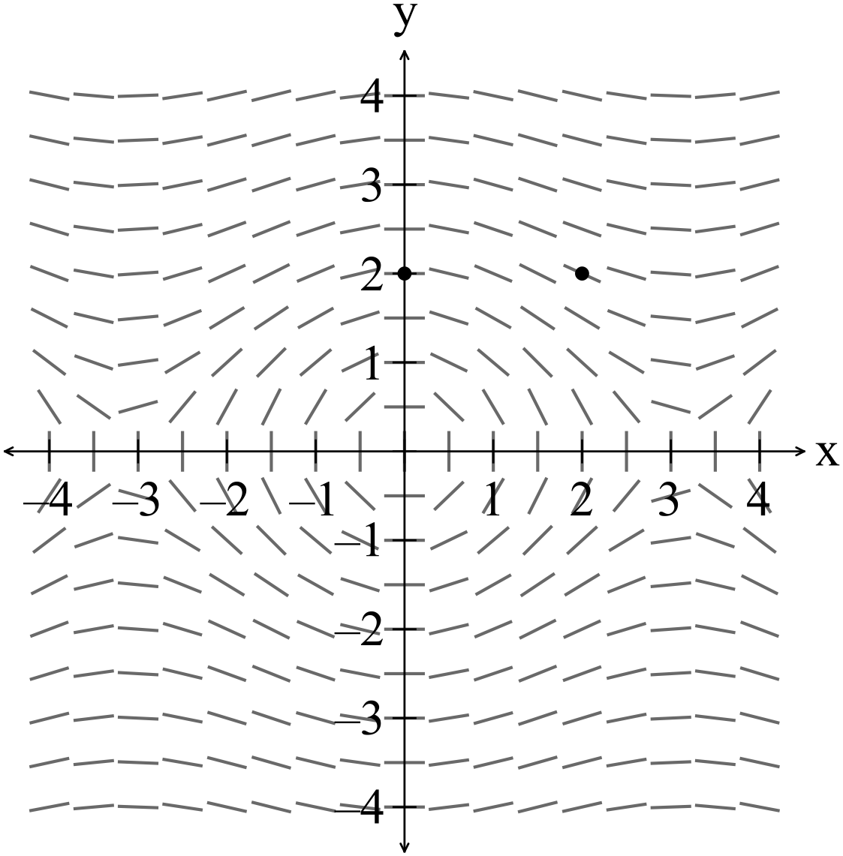

(b) What geometric conclusions can be made about the vectors  if

 Assume that each vector is not equal to the zero vector and that

 are not parallel vectors. (2)

**Question 21 (5 marks)**

Use integration to find the volume of a cone with height 10cm and base circumference 10 $π$ cm.

Additional working space

Question number: _________

Additional working space

Question number: _________